Body

1. Please identify where the headlight of the car is located.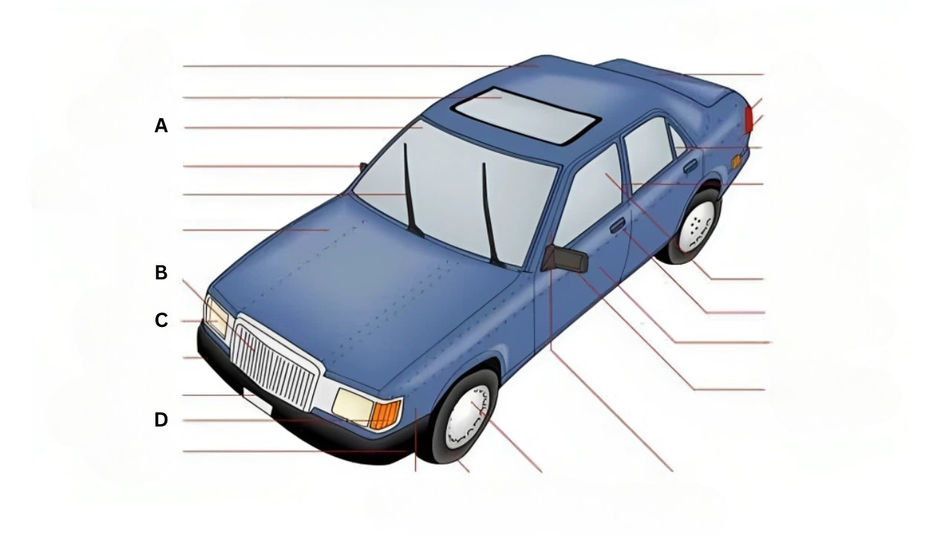

A. A

B. B

C. C

D. D

**Correct answer:** C

1. Please identify where the hood of the car is located.

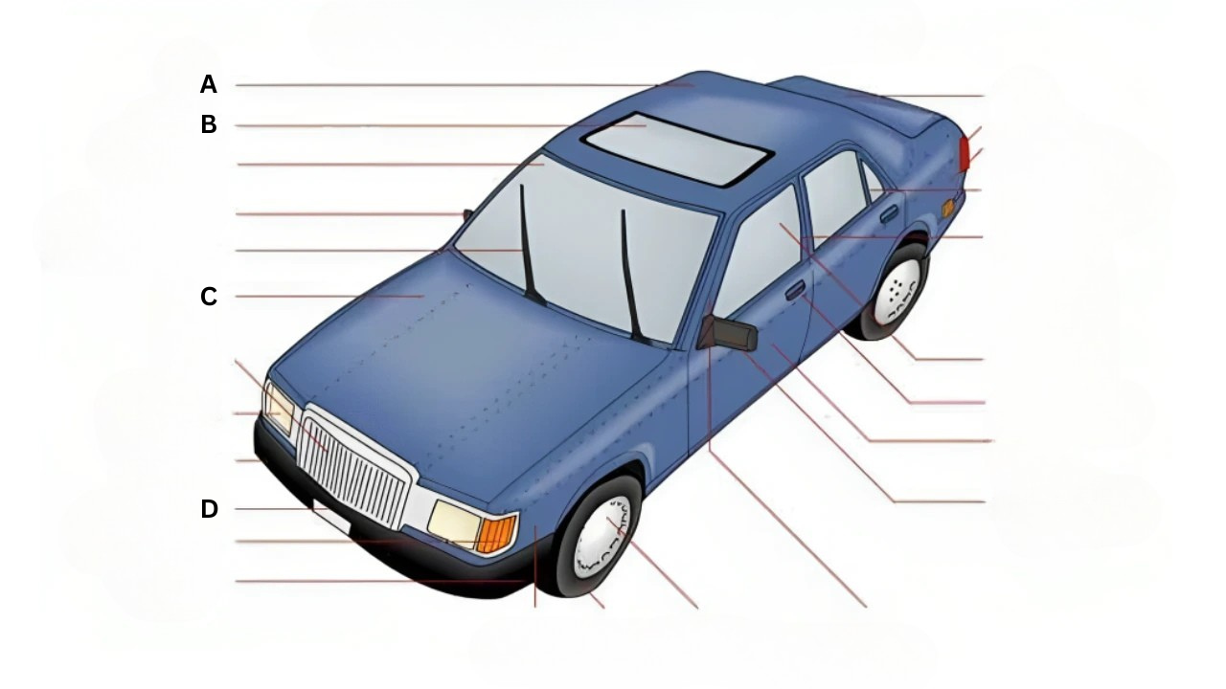A. A

B. B

C. C

D. D

**Correct answer:** A

1. Please identify where the door of the car is located.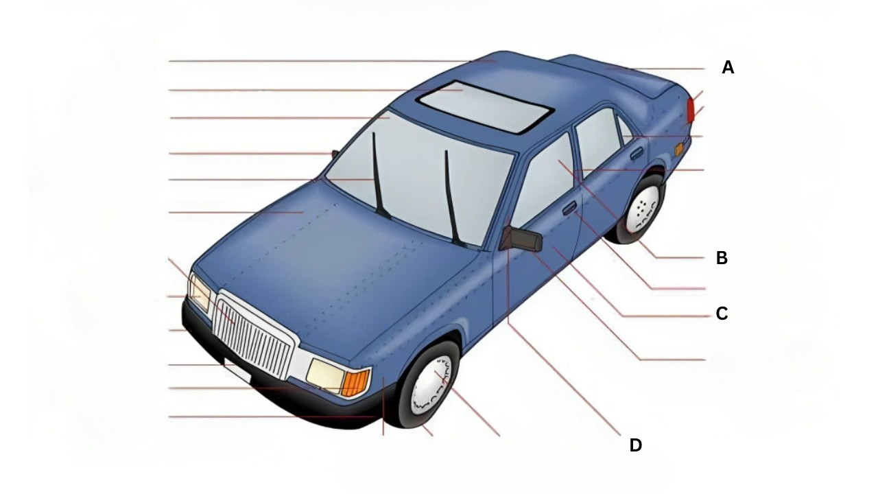

A. A

B. B

C. C

D. D

**Correct answer:** C

1. Please identify where the tailight of the car is located.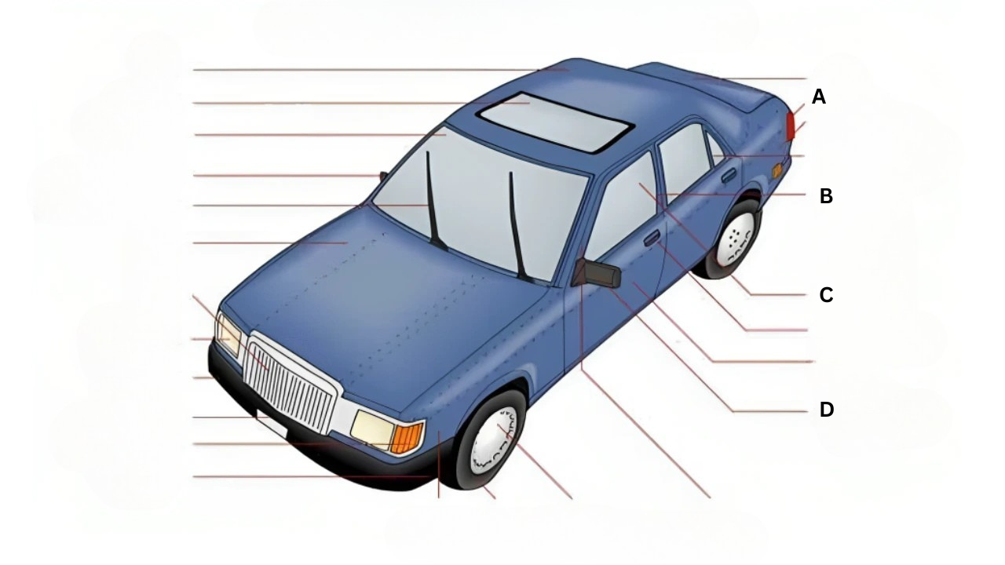

A. A

B. B

C. C

D. D

**Correct answer:** A

1. Please identify where the window of the car is located.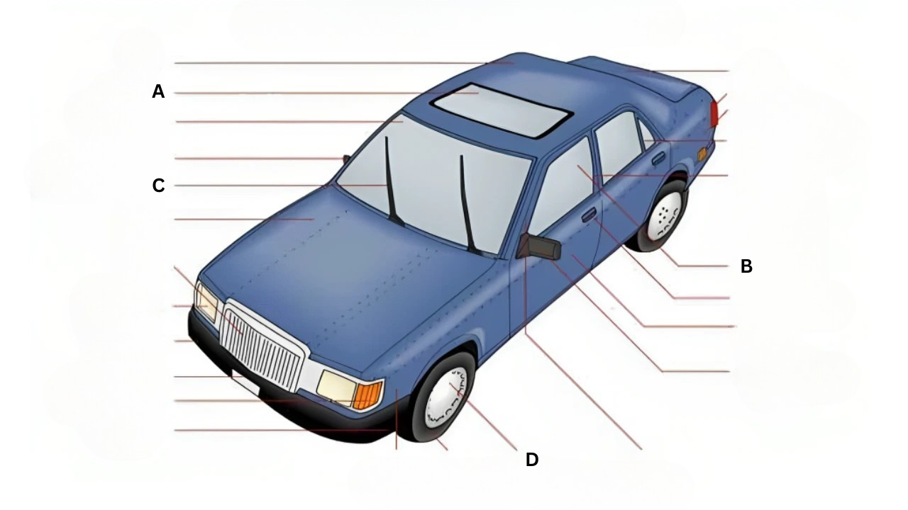

A. A

B. B

C. C

D. D

**Correct answer:** B